Da

Effective Use of Country-by-Country Reporting Data
19 – 21 November 2024 – 9.00am – 12.00pm (Paris Time/CET)
VIRTUAL WORKSHOP
Hosted by
The China and Korea OECD Multilateral Tax Centres

Languages: English with French, Mandarin and Russian interpretation

Level: Beginners to Intermediate

Objectives: See specific objectives for each session below

Target audience: See specific target audience for each session below. In particular, the sessions as part of Day 1 are particularly relevant for officials responsible for international taxation or BEPS implementation in jurisdictions that have not yet commenced implementation of the Action 13 Minimum Standard or have only partially implemented and wish to understand the benefits that can be achieved from receiving CbC reports and the data they contain. Sessions in Day 2 and Day 3 are targeted specifically for tax administration officials who will use/already use CbC reports as part of their work.

Format: This virtual workshop will be led by experts from the OECD Secretariat with support from OECD country experts.

Materials: Will be available to download after the event via the Knowledge Sharing Platform (KSP_{TA}) in English.

Effective Use of Country-by-Country Reporting Data
19 – 21 November 2024 – 9.00am – 12.00pm (Paris Time/CET)

Event leader(s):
Mr. Mark, JOHNSON (OECD Secretariat)
Ms. Nicole, CASEY (OECD Secretariat)
Mr. Matthew, COAKLEY (OECD Secretariat)

Experts:
Ms. Mayra, LUCAS (OECD Secretariat)
Mr. Mark, SCOTT (OECD Secretariat)
Mr. Lloyd, GARROCHINHO (OECD Secretariat)
Ms. Suhani, ANUAR (Malaysia)
Ms. Hannah, HASHEMI (UK)
Mr. Andreas Rossi, DEWANTARA (Indonesia)
Mr. Paul, WILSON (Australia)
Ms. Klara, KOWALSKA (Poland)
Mr. Fikrat, ABDULLAYEV (Azerbaijan)
Ms. Mariyam, IBHA JALEEL (Maldives)
Note: The topics listed are the topics proposed to be covered each day. The time allocated to each topic, as well as the timing of breaks, may vary.

Day 1 – 19 November 2024
9h00- 9h15  (15 min) | Welcome Remarks | Laurent Cytermann, OECD
9h15- 10h30  (75 min) | Session 1: Benefits of CbC reporting data  Target Audience:  - All jurisdictions.  - For jurisdictions where little to no implementation progress has been made, this session is targeted at officials with responsibility for international taxation and BEPS implementation.  - For jurisdictions that have implemented the minimum standard, auditors, risk assessors, and any tax administration staff with access to CbC reporting data will benefit from this session.  Objectives:  - To provide a detailed overview of the benefits that the data contained in CbC reports can provide to tax administrations, and the tools and support that will be made available to a tax administration in using CbC reports in undertaking a risk assessment.  - To provide input from subject matter experts in jurisdictions that have fully implemented the Action 13 Minimum Standard. | Mark Johnson, OECD  Suhani Anuar, (Malaysia)  Hannah Hashemi, (UK)  Andreas Rossi Dewantara, (Indonesia)
10h30- 10h45  (15 min) | BREAK
10h45- 12h00  (75 min) | Session 2: Overview of Action 13 – Master File and Local File  Target Audience:  - As above.  Objectives:  - To provide an overview of the transfer pricing documentation requirements which form part of Action 13 but are not part of the Minimum Standard, and how the three-tiered approach to transfer pricing documentation can be beneficial for risk assessment. | Mayra Lucas, OECD,  Paul Wilson (Australia)  Klara Kowalska (Poland)

Day 2 – 20 November 2024
9h00- 09h30  (30 min) | Session 3: Overview of Action 13 – CbC Report and the Peer Review Process  Target Audience:  - Tax administration officials responsible for the implementation of CbCR and the use of CbC reports for risk assessment.  Objectives:  - To provide a high-level overview of the building blocks required to be implemented in order to meet the Minimum Standard.  - Provide guidance on the information contained within a CbC report.  Provide a detailed overview of the peer review process and the Secretariat support available to assist jurisdictions in making progress in meeting the Minimum Standard. | Nicole Casey, OECD
9h30- 10h15  (45 min) | Session 4a: Building Blocks of CbC – Legislation, Exchange of Information and Appropriate Use  Target Audience:  - Tax administration officials responsible for the implementation of CbCR and the use of CbC reports for risk assessment.  Objectives:  - To provide a detailed overview of the building blocks required to be met in order to meet the Action 13 Minimum Standard.  - Provide details of the legislative requirement for CbCR.  - Overview of implementing exchange processes and exchange relationships for sending and receiving CbC reports.  - Details of the ways in which CbC reports can and cannot be used for risk assessment. | Nicole Casey, OECD
10h15- 10h40  (25 min) | BREAK
10h40- 11h15  (35 min) | Session 4b: Country Interventions – Challenges and Successes of CbCR Implementation  Objectives:  - Hear from jurisdictions that have put in place the various building blocks of the Minimum Standard as they share experiences, challenges and successes.  - Opportunity for Q&A. | Fikrat Abdullayev, (Azerbaijan)
11h15- 12h00  (45 min) | Session 5: Confidentiality Assessment for Automatic Exchange of Information  Target Audience:  - Tax administration officials from jurisdictions that have not yet passed the Global Forum confidentiality assessment for Automatic Exchange of Information  Objectives:  - Provide an overview of the support available from the Global Forum to assist jurisdictions in preparing for the confidentiality and data safeguards assessment.  - Provide details on a CbCR only assessment (i.e. without needing to commit to CRS).  - Provide details on the “secure perimeter” approach. | Lloyd Garrochinho, OECD

Day 3 – 21 November 2024
9h00- 09h45  (45 min) | Session 6: The Common Transmission System  Target Audience:  - Tax administration officials from jurisdictions that have not yet implemented the CTS or those that have questions about the CTS and how it works.  Objectives:  - Provide an overview of the CTS and its functionality.  - Address any issues raised by jurisdictions in respect of the CTS. | Mark Scott, OECD
09h45-09h55  (10 min) | Workshop Survey | GRP staff
09h55-10h10  (15 min) | BREAK
10h10- 10h55  (45 min) | Session 7: IT Systems – Developing versus Procuring, including country experience  Target Audience:  - Jurisdictions that have not yet put in place a domestic IT solution to connect to the CTS, or jurisdictions who wish to understand the various options available in respect of IT capabilities.  Objectives:  - Provide an overview of the various options available for implementing domestic IT systems to connect to the CTS.  - Share experience of a small jurisdiction that successfully implemented a low-cost off the shelf solution.  - Opportunity for Q&A. | Matthew Coakley, OECD  Ms. Mariyam Ibha Jaleel (Maldives)
10h55-11h45  (50 min) | Session 8: Using CbCR Data Effectively – The TREAT  Target Audience:  - Tax administration officials that use/will use CbC reports as part of their day-to-day work on risk assessment.  Objectives:  - Detailed guidance on the TREAT – the Tax Risk Evaluation and Assessment Tool – and its use in risk assessing the data contained in CbC reports. | Matthew Coakley, OECD
11h45- 12h00  (15 min) | Q&A and Closing Remarks | Laurent Cytermann, OECD

ANNEX 1: KSP_{TA} REGISTRATION

Follow the steps below to register for the KSPTA.

- Go to www.ksp-ta.org.  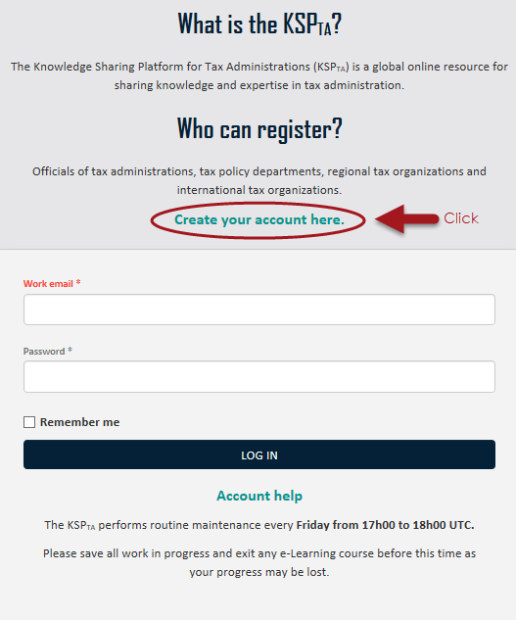  Click “Create your account here.” | - Complete all fields of the online form and use your work email. In the field country/organization, select your own country.  Click “Register” at the bottom.  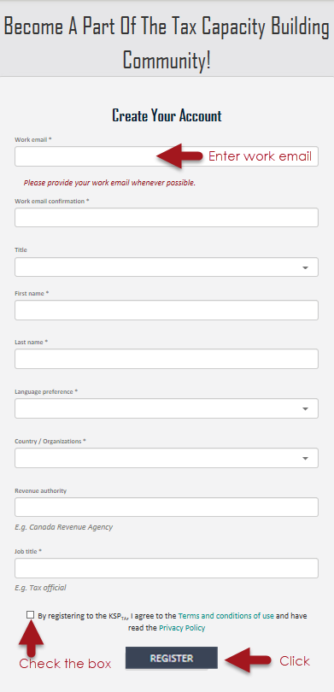

- You will receive an email to confirm your email address, click “Confirm account”. If you have not received it, check your spam folder or contact info@ksp-ta.org
- Once approved, you will receive another email. Click “Create password” and follow the instructions. You can now access the KSP_{TA}.
Note: The link expires in 10 days. After expiration, go to “Account help” and click “Reset Your Password”.

