THE SEVENTH MEETING OF THE ASIA PACIFIC NETWORK ON ACCESS TO MEDICINES UNDER UNIVERSAL HEALTH COVERAGE
Summary Report
13-14 June 2023, The Leela Palace, New Delhi, India

Background
Equitable quality health services and the fulfillment of universal health coverage (UHC) goals heavily rely on access to medicines and health technologies.
However, access to medicines, financing, pricing, and reimbursement pose significant challenges for many countries in the Asia Pacific and unfortunately, the COVID-19 pandemic has further aggravated this situation.
Often, medicines are either not adequately covered by benefit packages and health financing schemes, resulting in substantial out-of-pocked expenses for patients. In addition to elevated prices, this adds to the burden of healthcare costs.
Therefore, well-designed policies that govern medicines management are critical in ensuring the affordability and sustainability of financing for medicines.
The Asia Pacific Network on Access to Medicines under Universal Health Coverage was established in 2014. The network was set-up through a joint initiative of the WHO (Regional Office for the Western Pacific and Regional Office for South-East Asia), the Organization for the Economic Co-operation and Development (OECD) Korea Policy Centre, and the Seoul National University.
The network has played a crucial role in supporting the generation of evidence and data through collaborative surveys and research. Furthermore, the network has served as a platform for capacity building in various areas, such as health technology assessment and price negotiations.
The 7th Meeting of the Asia-Pacific Network on Access to Medicines under UHC aims to discuss challenges faced by the countries in building resilient supply chains responding to public health emergencies, exchange good practices on pricing policies and price monitoring, and improving access to medical products at primary health care towards achieving UHC.

Meeting Objectives

The aim of the workshop was to exchange good practices on pricing policies and price monitoring and improving access to medical products at primary health care towards achieving UHC.
- Discuss emerging challenges on access to medicines during and after public health emergencies and how to strengthen preparedness and build resilient supply chain;
- Share current challenges and best practices on pharmaceutical pricing and price information exchange; and
- Discuss improving access to medical products at primary health care including NCD services

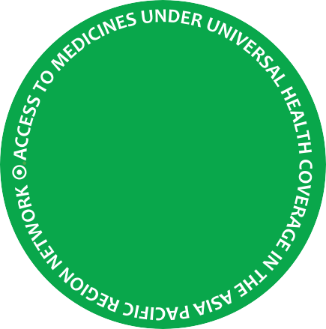
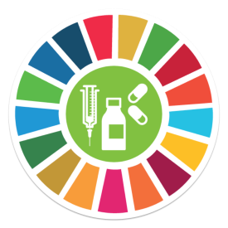
- Update on country situations on access to medical products and discuss relevant policies to improve availability, affordability and price of medical products


7th

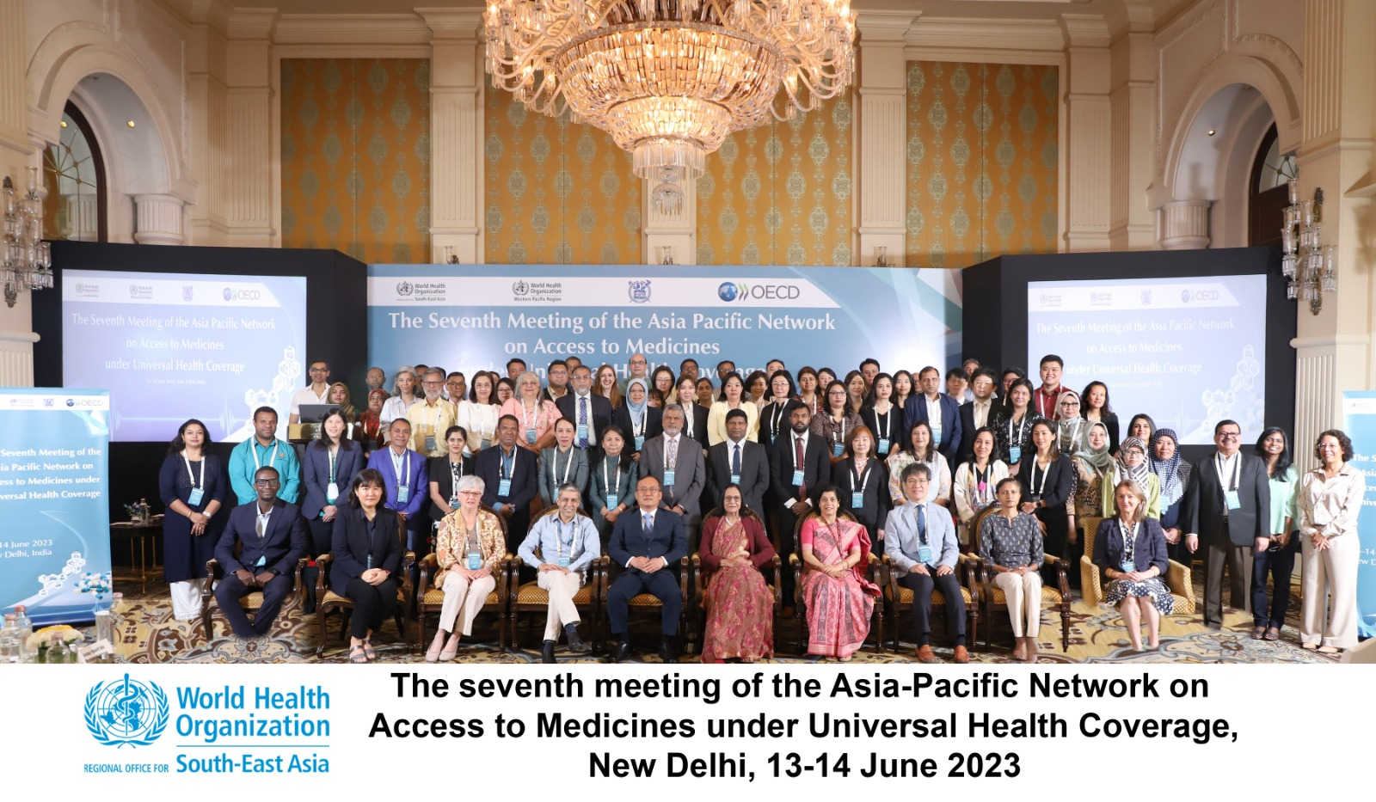
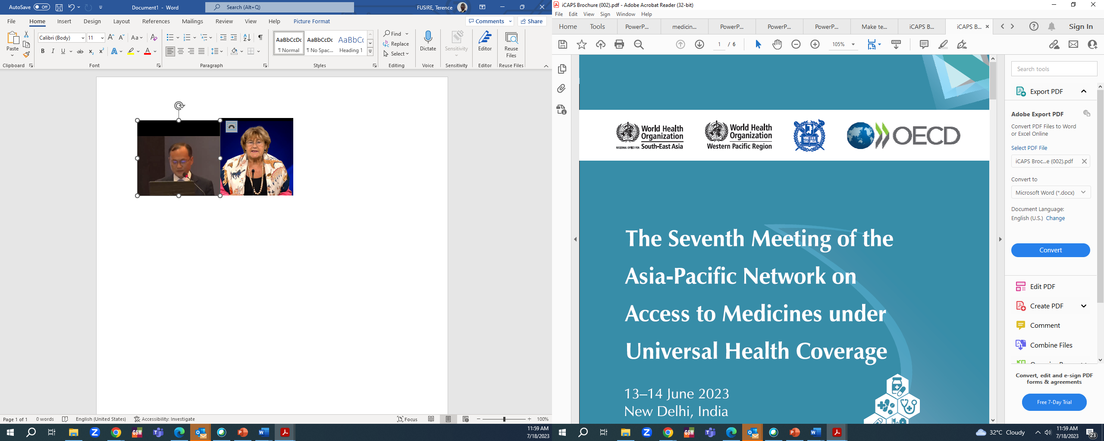

Programme, participating countries & network updates

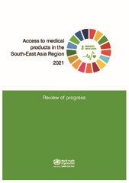

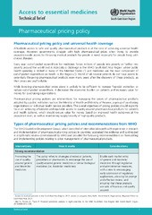

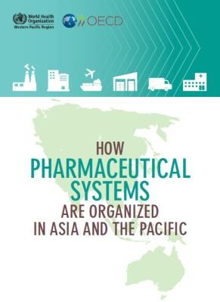
WHO Regio
Director-General
Wo ld Health Organization
How pharmaceutical
systems are organized in Asia and the Pacific August 2018
Featuring country
pharmaceutical profiles
Access to Essential Medical Products in the South-East Asia Region
September 2021
Featuring country
pharmaceutical profiles
RECENT POLICY BRIEF
Technical Brief: Pharmaceutical Pricing Policy
September 2022
NETWORK UPDATES
Overview of programme:
Day 1.
- COVID-19 and changing health systems and pharmaceutical systems in Asia-Pacific
- Global and Regional overview on access to medicines
- Emerging challenges on access to medicines during and after public health emergencies and building resilient supply chain
Day 2.
- Pharmaceutical pricing policy and price exchange
- Improving access at Primary Health Care and for NCDs
- Regional and cross-country collaboration


This Network was designed to achieve collaborative learning for accelerated health impact. By sharing maps and coordinates, signposts and trail-markers, together we will reach our destination quicker.
Dr Poonam Khetrapal Singh
Regional Director WHO South-East Asia Region

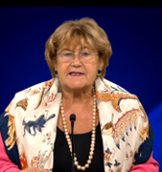
Access to health care is a human right, and we have an obligation to ensure the progressive realization of this right and guarantee access to essential medicines.
Dr Zsuzsanna Jakab, Ag. Regional Director
Western Pacific Region

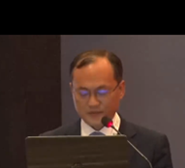
This network is an opportunity to face the current challenges and propose a direction to improve pharmaceutical pricing policies and access especially at PHC, build resilient supply chain strengthen collaboration. Daesik Lim
Director General
OECD Korea




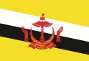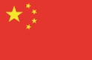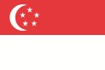
Viet Nam
Timor-Leste
Papua New Guinea
Fiji
Participating countries:
Bangladesh
India
Mongolia
Singapore
Bhutan
Indonesia
Sri Lanka
Brunei
Darussalam
Lao PDR
Nepal
Thailand
Malaysia
Philippines
China
Maldives
WHO South-East Asia Region (SEAR)
WHO Western Pacific Region (WPR)
The Seventh Meeting of the Asia-Pacific Region on Access to medicines under Universal Health Coverage 13-14 June 2023 New Delhi, India
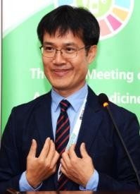
Asia-Pacific Network Progress
The network was proposed during the first Meeting on Access to Medicines under Universal Health Coverage in the Asia Pacific Region in September 2014.

During the second meeting in 2015, consensus was reached among Member States on the network's goals, governance structure, and areas of collaboration.

The third meeting in 2016 focused on improving access to high-cost medicines and sharing information on regulatory processes related to benefit package inclusion, procurement, reimbursement mechanisms, and financing options and the fourth meeting 2017 prioritized on ensuring affordable prices and strategic procurement of essential medicines.
The 6th meeting, held in Manila, in 2019 covered the implication of access on ageing population and discussed good practices on selection, rational use and monitoring framework

Workshop Modality
The 7th meeting was the first face-to-face meeting after 3 years of hiatus due to the COVID-19 pandemic.

The workshop was conducted in-person, with both onsite presentations, virtual broadcasting through WHO Zoom Platform. Approximately 90% of the participants were attending the network workshop for the first time.

WHO SEARO hosted the bi-regional meeting.

Category of Participants
- National focal points Medicine selection, pricing, financing, and development of pharmaceutical policies
- National focal persons responsible for procurement and supply chain management of essential medicines
- National focal persons responsible for Health Technology Assessments
- WHO Country Office

Keynote Presentation Prof. Soonman Kwon
- Investment into strengthening health systems and UHC is a fundamental solution for the preparedness and response to a pandemic as well as resilience.
- Effective targeting and protecting of the vulnerable: elderly, poor, migrant workers, residents in vulnerable environments.
- Prioritise investments in HR, capacity; production procurement and distribution of essential medical products; health systems strengthening and UHC; supply chains and regulatory processes.
- Strengthen governance through multi-sectoral cooperation of public and private sectors, central and local governments, and across different ministries and sectors.

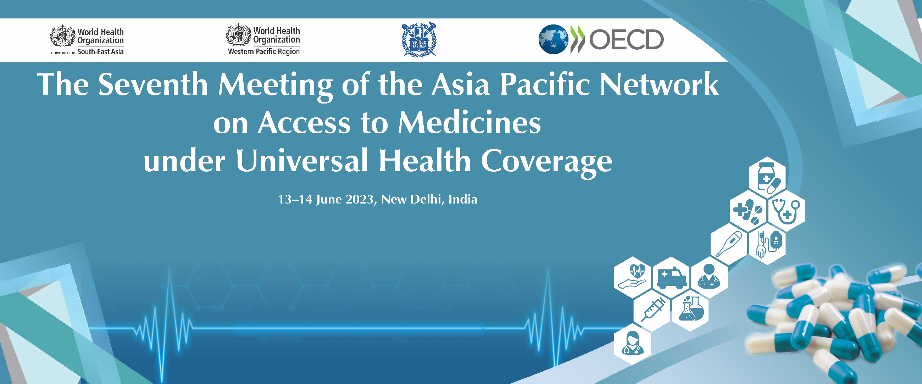





Country spotlights & session highlights: Emerging Challenges on access to medicines from the pandemic

COUNTRY SPOTLIGHTS

Bhutan
- Landlocked country with no local production and depended on imports.
- During COVID-19 pandemic supply chains were disrupted because of lockdowns.
- Explored bilateral diplomatic arrangements to facilitate procurement.

Brunei Darussalam
- Country dependent on imports with no local production capacity.
- Export restrictions from countries affected medicine supply during pandemic.
- Currently diversifying the supplier base to improve supply security.
- Geographic distribution a major challenge to the countries many islands.

Fiji
- Small country dependent on imports with no local production capacity.
- Export restrictions from countries affected medicine supply during pandemic.
- Used diplomatic relations to facilitate supply.
- Increasing medicine prices is now of concern to ensure sustainable supply by the government that provides free access to medicines.

India
- Pharmaceutical industry faced supply chain challenges with API procurement during the pandemic
- Maintained routine essential health services was a challenge.
- Policy decision to scale up domestic manufacturing capacity esp. of API.
- OOP being monitored using the national health accounts and has been reduced from 66% to 47%.
- Revised the EML in 2022.

Sri Lanka
- Severe drawback in the supply chain worsened by economic instability during the pandemic.
- Special procurement committee appointed to facilitate supply during the pandemic.
- External partners and donors supported the country during the pandemic.
- Efforts to strengthen local production capacity underway.

Papua New Guinea
- Maintaining essential health services during COVID-19 was a challenge.
- Public health infrastructure and workforce inadequate.
- Severe challenges in distribution within the country.
- Plans now underway to improve infrastructure and
health workforce

SESSION HIGHLIGHTS

✜ Pharmaceutical policies for UHC – Global Perspective

- Rising medicine costs is an important policy area and unaffordable medicine prices have become a pressing and aggravating concern in all countries.
- Prices of some established essential medicines have now become unaffordable, even in high-income countries.
- There is Increasing public expectation to have early access to ‘innovative’ medicines.
- Areas for identified by WHO for improving affordability and accessibility include strengthening pricing policies, improving efficiency and transparency.

✜ Access to medicines in South-East Asia Region

- The Region committed to ensure access to medical products, through the 2018 Delhi Declaration.
- High out of pocket expenditure on medicines is mainly driven by low availability of essential medicines in public facilities.
- Results from a regional policy analysis showed that policies commonly used in all countries include promotion of generic medicines, tendering, and making available free essential medicines in the public sector.

✜ Access to medicines in Western Pacific Region
- All countries share challenges in universal access to medicines that include inadequate financing, inefficiencies, limited pricing policies.
- Regional initiatives currently ongoing include Price Information Exchange for Medical (PIEMEDS) and the Western Pacific Regional Antimicrobial Consumption Surveillance System (WPRACSS).
- The Region approach ensures that medicine policies are embedded in government health policies.

✜ Ready for the Next Crisis? Investing in Health System Resilience
- Securing resilient supply chains in essential medical products is vital in the fight against future crises.
- Closer cooperation and communication between governments is needed to improve preparedness in public health crises
- Closer cooperation between countries is needed to avoid inefficient stockpiling strategies duplicating national stocks and blocking essential medicines from effective distribution based on needs





Country spotlights & session highlights: Pricing Policy, PIEMEDS and Primary Health Care

COUNTRY SPOTLIGHTS

Bangladesh
- Locally produces 98% of essential
Medicines.
- A price fixation committee set the maximum retail price (MRP) of medicines.
- Major challenge is ensuring affordability of non-listed medicines.

Indonesia
- Country currently undergoing health system transformation.
- The supply of essential medicines is guaranteed by the Government.
- Medicine procurement and planning is based on e-Catalogue to ensure transparency and efficiency.
- Drug selection based on Benefit-Risk Ratio and Benefit-Cost Ratio considerations (EBM, HTA, Pharmacoeconomic studies.)
- Efforts underway to improve availability and affordability under the National Health Insurance.

India
- India declared a target of 75 million individuals with NCDs on standard dare by 2025.
- Medicine supply is a key component of the initiative along with standard treatment protocols.
- This has lead to improved availability of protocol medicines in PHC facilities, The cost of treatment has significantly reduced.
- The challenge is that procurement systems for medicines varies from state to state and that private sector prefers fixed dose combinations.

Mongolia
- Share of medicine budget in the health sector budget averaged 10-14% but significantly increased to 50% during COVID-19.
- Medicine OOP expenditure at 74% of total OOP on health.
- Reimbursement by health insurance provides 30-100% discount medicines on the reimbursement list.
- There no medicine regulation policy and medicine price notably increasing.

Philippines
- Pharmaceutical spending almost a fifth of current health expenditure.
- The price of medicines is a huge barrier to access.
- Procurement and distribution affect availability of medicines at PHE and policy seeks to ensures drug supplies through market creation by linking health facilities with drug stores.

Thailand
- Temporary shortage of medicines still an unfinished agenda
- There is need for efficient stock management to reduce dead stock.
- Some policy incoherence that is being followed up,

SESSION HIGHLIGHTS

✜ WHO Guideline on Pricing Policy

- High prices of pharmaceutical products have led to significant financial hardship and negatively impact healthcare systems’ ability to provide population-wide access to essential medicines.
- Well-thought-out policies can guide well-informed and balanced decisions to achieve affordable access to essential health products.
- The guideline development group made strong recommendations on “promoting the use of quality assured generic and biosimilar medicines”

✜ Pharmaceutical pricing policy for reimbursement

- New technologies come with high price and can potentially escalate financial stress.
- Prioritizing limited resources need to balance between efficiency and equity.
- With ERP, pharmaceutical expenditure can be contained or even decline at least in the short term.

✜ Medicines price information in South-East Asia
- A regional survey conducted in 2022 highlighted the current pharmaceutical systems, availability of data on price components, and data sources, to understand the price and explore price information exchange in a standard format.
- The survey provided the foundation for the development and/or implementation of a medicine price exchange platform for South-East Asia Member States.

✜ PIEMEDS platform
- The PIEMEDS’ goal is to strengthen access to medicines by enhancing efficiency of procurement based on timely information on market and pricing dynamics.
- The platform is built to promote price transparency through a secure platform enabling collection, access to and analysis of pricing data shared.

✜ Challenges of access to medical products at PHC and SEARO roadmap on PHC
- The Region noted that the pandemic provided a “Once in a century opportunity” to enable PHC oriented transformation.
- Subsequently, the PHC forum was started to drive transformation of health systems with a TWG focusing on essential medicines.

PRICE INFORMATION EXCHANGE
- Procurement systems
- Enhanced transparency
PIEMEDS

- Key features
- Information Included
- Dashboards
PROPOSED COLLABORATIVE ACTIONS

- Information Sharing on Prices between countries
  - Voluntary up to date price disclosure
  - PIEMEDS platform database management
  - Legal and regulatory frameworks, confidentiality agreements
- Sharing best Practices
  - Establishing collaborative networks among countries
  - Bilateral and Multilateral Agreements
- Evidence Based selection
  - Sharing and utilization Health Technology Assessment information
- Joint medicine procurement efficiency scheme
  - Explore collaboration in price negotiation
- Advocacy efforts for fair pricing
  - Transparency in Pricing
  - Strengthening Regulatory Authorities
- Measure progress
  - Need for better data and clear indicators to monitor access to medicines (e.g. better data on OOP, mobile app for availability and price)
SUPPLY RESILIENCE

- What policy options?
- Who benefits?
WHAT DO YOU WANT FROM THE NETWORK

- Maintain focus on access to medicines.
Proposed value-added of network to facilitate sharing information on pharmaceutical policy (e.g. review implementation of national policies to increase access and affordability of high-cost medicine(s) across network members; highlight policy learning via case studies).

- Enhance PIEMEDS for price information sharing.
Re-visit process of submitting prices to PIEMEDS platform.

- Continue informal networking.
Connect beyond meeting to support each other, share intelligence and experiences.

- Capacity building.
Conduct training focused on pricing policy review and implementation, generic medicines, and biosimilar pricing strategies.
NETWORK OBJECTIVES

- Collect and share information on pharmaceutical policies and strategies to generate evidence on the impact of policies to enhance access to medicines;
- Build institutional and human capacity for effective medicines policy development and implementation of practices under universal health coverage;
- Exchange information for decision-making, including information on pricing, cost and value of medicines;
- Share experiences through regular network meetings and/or through suitable virtual communication.

FUTURE AREAS OF INTEREST
- Generic medicines and biosimilars
- Innovative medicines
- Health Insurance Package
- Regulation of Private sector
- Price negotiation
SKILLS DEVELOPMENT
- In-person workshops
- Online courses
- Webinars
- Peer learning
PHC and NCDs
- Last mile access
- Benefit package
- Expanded service though telemedicine
- Biosimilars
WHAT DID WE LEARN
- Strengthening preparedness and building resilient supply chains
- Best practices in pharmaceutical pricing and price information exchange
- Approaches in improving access in PHC

Ways forward and Potential Collaboration

