TRANSPARENCY AND INTEGRITY IN LOBBYING

Worldwide public concerns over lobbying and the OECD response
Concerns over lobbying practices and demands for transparency in public decision making have led to countries increasingly discussing lobbying in the political and policy arena. Lobbying can provide decision-makers with valuable insights and data, as well as grant stakeholders access to the development and implementation of public policies. However, lobbying can also lead to undue influence, unfair competition and regulatory capture to the detriment of the public interest and effective public policies. A sound framework for transparency in lobbying is therefore crucial to safeguard the integrity of the public decision-making process.
The OECD Principles for Transparency and Integrity in Lobbying have helped decision makers address concerns raised by lobbying practices. These are the only international principles addressing concerns raised by lobbying and providing guidance on how to meet expectations of transparency and accountability in the public decision-making process. They are part of the OECD strategy for a stronger, fairer and cleaner economy.


Lobbying in figures: Evidence of its size and impact

Lobbying is a global multi-billion dollar business that employs a considerable number of individuals. For example, in 2010, lobbying spending at the federal level in the United States reached the record figure of USD 3.5 billion. In 2013, the number of registered lobbyists at the federal level was 11 400, a slight decrease from the record number of 14 800 that was recorded in 2007. In Canada, the number of lobbyists at the federal level exceeds 5000. In Europe, close to 6000 lobbyist have voluntarily registered with the European institutions.
An International Monetary Fund Working Paper analysed lobbying intensity in a variety of industries in the USA. According to the paper “firms lobbying in financial, insurance and real estate corporations (FIRE industry) spent approximately USD 480 000 per firm in 2006 compared to USD 300 000 per firm in defense or USD 200 000 per firm in construction.” The paper established a link between intensive lobbying by the FIRE industry and high-risk lending practices, for example by using more lax lending standards measured by loan-to-income ratio. It concluded that the “prevention of future crises might require weakening political influence of the financial industry or closer monitoring of lobbying activities to understand the incentives better.”
What can governments do to enhance transparency and safeguard integrity?
In 2009, the OECD reviewed data and experiences of government regulation, legislation and self-regulation of lobbyists. Based on the evidence and lessons learned from comparative reviews, country case studies and an analytical framework endorsed by governments, the OECD developed 10 Principles.
What are the elements of strong lobbying regulation?
Experience suggests that effective regulation depends on the following elements:
- Definition of lobbyist and lobbying activities targeted by regulation are clear and unambiguous.
- Disclosure requirements provide pertinent information on key aspects of lobbyists and lobbying such as its objective, beneficiaries, funding sources and targets.
- Rules and guidelines set standards for expected behavior, for example to avoid misuse of confidential information, conflict of interest and prevent revolving door practices.
- Procedures for securing compliance are framed in a coherent spectrum of strategies and mechanisms, including monitoring and enforcement.
- The organisational leadership promotes a culture of integrity and transparency in daily practice through regular disclosure and auditing to ensure compliance.

Evidence from governments and lobbyists

What are the experiences of governments to enhance transparency and promote integrity?
Lobbying is a global practice. However, only a third of OECD countries have introduced government regulations and legislation. Since the 1940’s until early 2000s, only four countries regulated lobbying practices and since 2005 an additional eight countries have chosen to do so. These range from mandatory systems such as the ones in place in for example Canada or the United States, to the voluntary systems in place in for example France. Many OECD countries rely on self-regulation of lobbyists. The experiences reviewed by the OECD show that regulating lobbying has proven difficult for decision makers due to its complexity and sensitive nature. Furthermore, the process of regulating lobbying and reforming regulation that is already in place has so far been ad hoc, and largely in response to political scandals. Reaching the necessary consensus among stakeholders before scandals take place and mobilising enough political support has been challenging.
Australia, Canada, France, Germany, Hungary, Israel, Mexico, Poland, Slovenia, the United States, and most recently Austria and the Netherlands have approved legislation and government regulations. The European Parliament and Commission have jointly regulated lobbying.
Brazil, Chile, Ireland, Spain and the United Kingdom are debating draft laws and bills on lobbying.
What are the views of the lobbying industry and those who are lobbied?
Transparency of lobbying activities would help alleviate actual or

perceived problems of inappropriate influence peddling by lobbyists
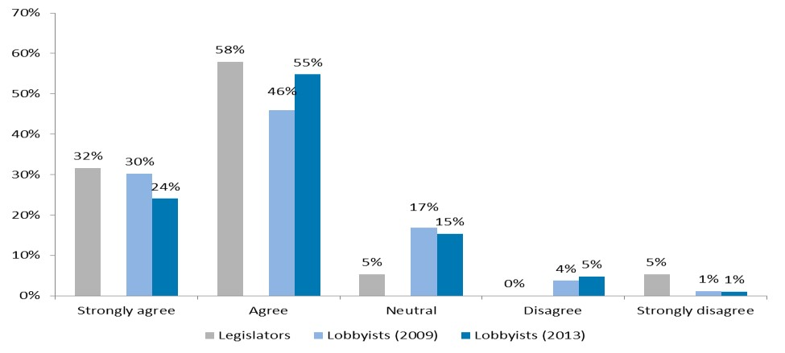
“It takes two to lobby.” The OECD has surveyed both lobbyists and those who are lobbied. The s urvey results show that there is a consensus among lobbyists as well as legislators that transparency of lobbying would help alleviate actual or perceived problems of inappropriate influence peddling by lobbyists. Nonetheless, achieving the adequate level of transparency in terms of the amount and types of information that should be disclosed, and ensuring the efficiency of disclosure tools or mechanisms used is still challenging for many countries.

Stakeholders believe that transparency of lobbying activities should be mandatory for all lobbyists
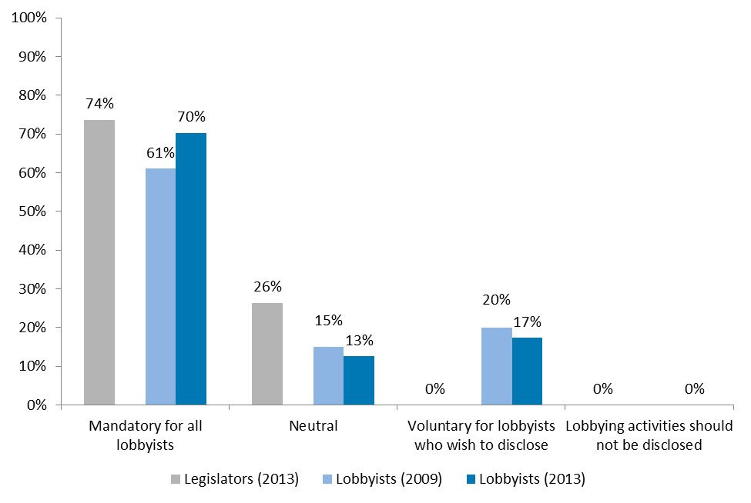
Despite the general perception that lobbyists prefer opacity with regards to the disclosure of their activities, the OECD’s surveys show that the majority of surveyed lobbyists support mandatory disclosure of information. This view is also shared by close to three quarters (74%) of surveyed legislators.

Sources: OECD 2013 Survey on Lobbying for Lobbyists, OECD 2013 Survey on Lobbying for Legislators and OECD 2009 Survey on
Lobbying for Lobbyists

The 10 Principles for Transparency and Integrity in Lobbying

I. Building an effective and fair framework for openness and access
- Countries should provide a level playing field by granting all stakeholders fair and equitable access to the development and implementation of public policies.
Public officials should preserve the benefits of the free flow of information and facilitate public engagement. Gaining balanced perspectives on issues leads to informed policy debate and formulation of effective policies. Allowing all stakeholders, from the private sector and the public at large, fair and equitable access to participate in the development of public policies is crucial to protect the integrity of decisions and to safeguard the public interest by counterbalancing vocal vested interests. To foster citizens’ trust in public decision making, public officials should promote fair and equitable representation of business and societal interests.
- Rules and guidelines on lobbying should address the governance concerns related to lobbying practices, and respect the socio-political and administrative contexts.
Countries should weigh all available regulatory and policy options to select an appropriate solution that addresses key concerns such as accessibility and integrity, and takes into account the national context, for example the level of public trust and measures necessary to achieve compliance. Countries should particularly consider constitutional principles and established democratic practices, such as public hearings or institutionalised consultation processes.
Countries should not directly replicate rules and guidelines from one jurisdiction to another. Instead, they should assess the potential and limitations of various policy and regulatory options and apply the lessons learned in other systems to their own context. Countries should also consider the scale and nature of the lobbying industry within their jurisdictions, for example where supply and demand for professional lobbying is limited, alternative options to mandatory regulation for enhancing transparency, accountability and integrity in public life should be contemplated. Where countries do opt for mandatory regulation, they should consider the administrative burden of compliance to ensure that it does not become an impediment to fair and equitable access to government.
- Rules and guidelines on lobbying should be consistent with the wider policy and regulatory frameworks.
Effective rules and guidelines for transparency and integrity in lobbying should be an integral part of the wider policy and regulatory framework that sets the standards for good public governance. Countries should take into account how the regulatory and policy framework already in place can support a culture of transparency and integrity in lobbying. This includes stakeholder engagement through public consultation and participation, the right to petition government, freedom of information legislation, rules on political parties and election campaign financing, codes of conduct for public officials and lobbyists, mechanisms for keeping regulatory and supervisory authorities accountable and effective provisions against illicit influencing.
- Countries should clearly define the terms 'lobbying' and 'lobbyist' when they consider or develop rules and guidelines on lobbying.
Definitions of 'lobbying' and 'lobbyists' should be robust, comprehensive and sufficiently explicit to avoid misinterpretation and to prevent loopholes. In defining the scope of lobbying activities, it is necessary to balance the diversity of lobbying entities, their capacities and resources, with the measures to enhance transparency. Rules and guidelines should primarily target those who receive compensation for carrying out lobbying activities, such as consultant lobbyists and in-house lobbyists. However, definition of lobbying activities should also be considered more broadly and inclusively to provide a level playing field for interest groups, whether business or not-for-profit entities, which aim to influence public decisions.
Definitions should also clearly specify the type of communications with public officials that are not considered 'lobbying' under the rules and guidelines. These include, for example, communication that is already on public record – such as formal presentations to legislative committees, public hearings and established consultation mechanisms.

II. Enhancing transparency
- Countries should provide an adequate degree of transparency to ensure that public officials, citizens and businesses can obtain sufficient information on lobbying activities.
Disclosure of lobbying activities should provide sufficient, pertinent information on key aspects of lobbying activities to enable public scrutiny. It should be carefully balanced with considerations of legitimate exemptions, in particular the need to preserve confidential information in the public interest or to protect market-sensitive information when necessary.
Subject to Principles 2 and 3, core disclosure requirements elicit information on in-house and consultant lobbyists, capture the objective of lobbying activity, identify its beneficiaries, in particular the ordering party, and point to those public offices that are its targets. Any supplementary disclosure requirements should take into consideration the legitimate information needs of key players in the public decision-making process. Supplementary disclosure requirements might shed light on where lobbying pressures and funding come from. Voluntary disclosure may involve social responsibility considerations about a business entity’s participation in public policy development and lobbying. To adequately serve the public interest, disclosure on lobbying activities and lobbyists should be stored in a publicly available register and should be updated in a timely manner in order to provide accurate information that allows effective analysis by public officials, citizens and businesses.
- Countries should enable stakeholders – including civil society organisations, businesses, the media and the general public – to scrutinise lobbying activities.
The public has a right to know how public institutions and public officials made their decisions, including, where appropriate, who lobbied on relevant issues. Countries should consider using information and communication technologies, such as the Internet, to make information accessible to the public in a cost-effective manner. A vibrant civil society that includes observers, 'watchdogs', representative citizens groups and independent media is key to ensuring proper scrutiny of lobbying activities. Government should also consider facilitating public scrutiny by indicating who has sought to influence legislative or policy-making processes, for example by disclosing a 'legislative footprint' that indicates the lobbyists consulted in the development of legislative initiatives. Ensuring timely access to such information enables the inclusion of diverse views of society and business to provide balanced information in the development and implementation of public decisions.

III. Fostering a culture of integrity
- Countries should foster a culture of integrity in public organisations and decision making by providing clear rules and guidelines of conduct for public officials.
Countries should provide principles, rules, standards and procedures that give public officials clear directions on how they are permitted to engage with lobbyists. Public officials should conduct their communication with lobbyists in line with relevant rules, standards and guidelines in a way that bears the closest public scrutiny. In particular, they should cast no doubt on their impartiality to promote the public interest, share only authorised information and not misuse ‘confidential information’, disclose relevant private interests and avoid conflict of interest. Decision makers should set an example by their personal conduct in their relationship with lobbyists.
Countries should consider establishing restrictions for public officials leaving office in the following situations: to prevent conflict of interest when seeking a new position, to inhibit the misuse of ‘confidential information’, and to avoid post-public service ‘switching sides’ in specific processes in which the former officials were substantially involved. It may be necessary to impose a ‘cooling-off’ period that temporarily restricts former public officials from lobbying their past organisations. Conversely, countries may consider a similar temporary cooling-off period restriction on appointing or hiring a lobbyist to fill a regulatory or an advisory post.
- Lobbyists should comply with standards of professionalism and transparency; they share responsibility for fostering a culture of transparency and integrity in lobbying.
Governments and legislators have the primary responsibility for establishing clear standards of conduct for public officials who are lobbied. However, lobbyists and their clients, as the ordering party, also bear an obligation to ensure that they avoid exercising illicit influence and comply with professional standards in their relations with public officials, with other lobbyists and their clients, and with the public.
To maintain trust in public decision making, in-house and consultant lobbyists should also promote principles of good governance. In particular, they should conduct their contact with public officials with integrity and honesty, provide reliable and accurate information, and avoid conflict of interest in relation to both public officials and the clients they represent, for example by not representing conflicting or competing interests.

IV. Mechanisms for effective implementation, compliance and review
- Countries should involve key actors in implementing a coherent spectrum of strategies and practices to achieve compliance.
Compliance is a particular challenge when countries address emerging concerns such as transparency in lobbying. Setting clear and enforceable rules and guidelines is necessary, but this alone is insufficient for success. To ensure compliance, and to deter and detect breaches, countries should design and apply a coherent spectrum of strategies and mechanisms, including properly resourced monitoring and enforcement. Mechanisms should raise awareness of expected rules and standards; enhance skills and understanding of how to apply them; and verify disclosures on lobbying and public complaints. Countries should encourage organisational leadership to foster a culture of integrity and openness in public organisations and mandate formal reporting or audit of implementation and compliance. All key actors – in particular public officials, representatives of the lobbying consultancy industry, civil society and independent 'watchdogs' – should be involved both in establishing rules and standards, and putting them into effect. This helps to create a common understanding of expected standards. All elements of the strategies and mechanisms should reinforce each other; this coordination will help to achieve the overall objectives of enhancing transparency and integrity in lobbying.
Comprehensive implementation strategies and mechanisms should carefully balance risks with incentives for both public officials and lobbyists to create a culture of compliance. For example, lobbyists can be provided with convenient electronic registration and report-filing systems, facilitating access to relevant documents and consultations by an automatic alert system, and registration can be made a prerequisite to lobbying. Visible and proportional sanctions should combine innovative approaches, such as public reporting of confirmed breaches, with traditional financial or administrative sanctions, such as debarment, and criminal prosecution as appropriate.
- Countries should review the functioning of their rules and guidelines related to lobbying on a periodic basis and make necessary adjustments in light of experience.
Countries should review – with the participation of representatives of lobbyists and civil society – the implementation and impact of rules and guidelines on lobbying in order to better understand what factors influence compliance. Refining specific rules and guidelines should be complemented by updating implementation strategies and mechanisms. Integrating these processes will help to meet evolving public expectations for transparency and integrity in lobbying. Review of implementation and impact, and public debate on its results are particularly crucial when rules, guidelines and implementation strategies for enhancing transparency and integrity in lobbying are developed incrementally as part of the political and administrative learning process.

The 10 Principles for Transparency and Integrity in Lobbying:
A Good Governance Approach

A unique international policy instrument with a comprehensive and non-prescriptive approach
The OECD completed a wide consultation in December 2009 with over a hundred stakeholders, including legislators, representatives of the private sector, lobbying associations, civil society, trade unions, think tanks, academics, and international and regional government organisations. All stakeholders acknowledged that the Principles were timely and relevant. The feedback signaled that the Principles properly address the main concerns and provide pillars for applying good governance principles in lobbying. Based on the results of the multi-stakeholder consultation, the consolidated Principles were adopted by the OECD Council as a Recommendation in 2010.
The Principles reflect experiences of countries with diverse socio-political and administrative contexts and provide guidance to decision makers in the executive and legislative branches at both national and sub-national level. The Principles were developed in parallel with the European Transparency Initiative and the Code of Conduct for Interest Representatives of the European Commission.

The way forward: Capitalising on the OECD principles to further reinforce a fair and inclusive decision-making process
In the Recommendation, the Council instructed the Public Governance Committee (PGC) to report to the Council on progress made in implementing this Recommendation in three years of its adoption and regularly thereafter. Three years later, the PGC is therefore taking stock of the progress made by Member and Key Partner countries. This process is an opportunity to review the evolution of risks and concerns, and identify lessons learned in designing and implementing measures and cost-effective solutions for safeguarding the integrity of the decision-making process.
Progress made in implementing the Principles for Transparency and Integrity in Lobbying
The review of the implementation of the OECD Recommendation shows that the approach and content of the Recommendation has proven applicable in different countries’ contexts and that the Principles have served as a reference in Member, Key Partner, and non-Member countries in designing or revising lobbying regulations and public decisionmaking processes. Yet, while the Recommendation continues to be relevant, the review of experiences in the past three years showed that evolutions in public decision making and lobbying practices have created new risks that could weaken citizens’ trust in government and compromise the fairness of the decision-making process. These deserve increased attention, and the actions that were identified to address these risks are:
- Strengthen efforts in addressing lobbying concerns and risks in the decision-making process as a key policy lever for trust.
- Invest in measuring benefits and costs, and monitoring performance.
- Identify and promote innovative integrity frameworks that reflect the needs and concerns of countries in the 21st century.
- Review policies for managing conflict of interest in relation to revolving door practices and the unbalanced representation and influence of advisory groups.
The review of implementation of the Recommendation builds on the policy dialogues that took place during the OECD High Level Parliamentary Seminars held in Santiago, Chile in March 2012 and in Paris in October 2013, France, and the views of the key actors – namely governments, lobbyists and legislators – collected through three surveys. In addition, the Public Governance Committee through the Public Sector Integrity Network organised a global policy debate during the OECD Forum on Transparency and Integrity in Lobbying on 27-28 June 2013 which brought together more than 100 senior representatives from the executive and legislative branches of governments, the private sector and civil society. The results of the review process will be published in 2014.

Further reading
A comparative review of potential and limitations of existing legislation and government regulations is available in Lobbyists, Government and Public Trust, Volume 1: Increasing Transparency through Legislation, OECD (2009).
A comparative analysis of laws, policies and measures taken in OECD countries for avoiding conflict of interest when officials leave public office is available in Post-Public Employment: Good Practices for Preventing Conflict of Interest, OECD (2010).
Results of the OECD survey conducted amongst the largest sample of lobbyists and experiences on self-regulation applied by lobbyist associations is available in Lobbyists, Government and Public Trust, Volume 2: Promoting Integrity by Selfregulation, OECD (2012).

